Introduction to Parabolas
Terminology:
Quadratic Expression
vs.
Quadratic Equation
vs.
Quadratic Function

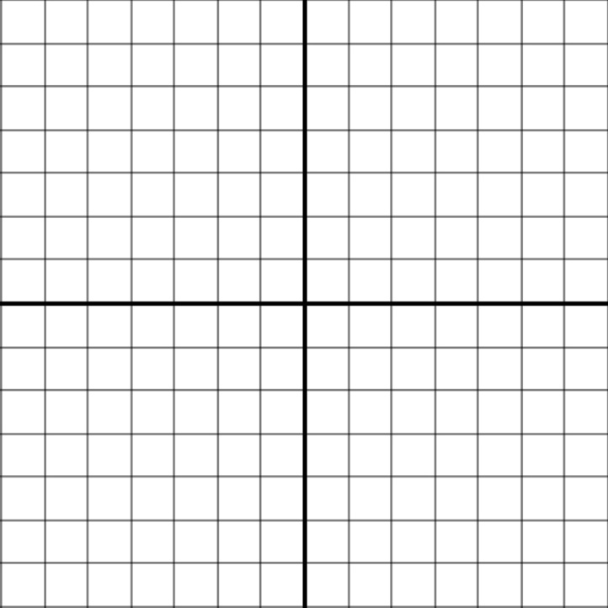
What does a Quadratic Function look like when it is graphed? To find out, let’s use a t-table and graph the simplest Quadratic Function: $y=x^{2}$.
x | y
-3
-2
-1
0
1
2
3

Vocabulary:
1) Parabola:
2) Vertex:
3) Line or Axis of Symmetry:
4) Y-intercept:
5) X-intercept(s):
How would the graph change if we multiplied the x² by a coefficient of a?
Group 1: $y={2x}^{2}$
Group 2: $y={-x}^{2}$
Group 3: $y={\frac{1}{2}x}^{2}$
Group 4: $y={5x}^{2}$
Group 5: $y=-2x^{2}$
Group 6: $y=-{\frac{1}{4}x}^{2}$
Directions: Using a t-table (you may use the same one as in the last example), graph your quadratic function on the large graph paper provided. Make sure to use markers to plot the points neatly.

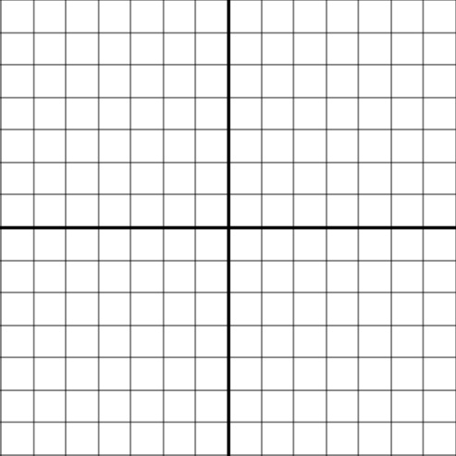





Sketch a graph of each of the groups’ graphs here, including your own:
Group 3:
Group 2:
Group 1:
Group 6:
Group 5:
Group 4:
What does the value of $a$ do to the graph of $=ax^{2}$ ?

Now let’s figure out what the value of c does to the graph, when we add c, so that we get the function: $y=ax^{2}+c$.
Sketch each graph:


Eqt. 1: $y=x^{2}+3$ Eqt. 2: $y=x^{2}-5$



Eqt. 3: $y=x^{2}+1$ Eqt. 4: $y=x^{2}-4$

Summary: Summarize what we have learned today:

